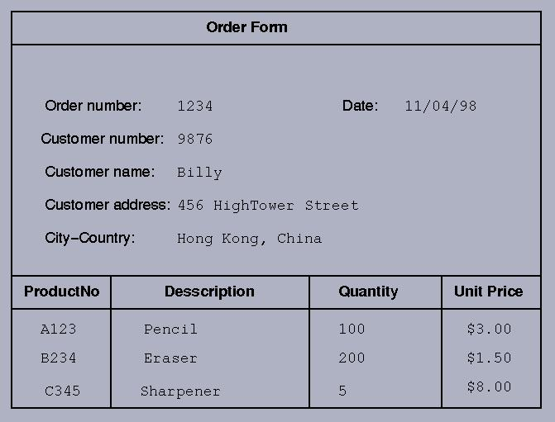

A Sample Answer
- UNF
  - ORDER(order#, customer#, name, address, orderdate, product#, description, quantity, unitprice)

- 1NF

- 2NF

- 3NF

